AI Assisted Coding (III Year)
Assignment – 10.5
Name: B. Rithwik
HT NO: 2303A52330
Batch: 35

Lab 10 – Code Review and Quality: Using AI to Improve Code Quality and Readability

Lab Objectives:
- Use AI for automated code review and quality enhancement
- Identify and fix syntax, logical, performance, and security issues in Python code
- Improve readability and maintainability through structured refactoring and comments
- Apply prompt engineering for targeted improvements
- Evaluate AI-generated suggestions against PEP 8 standards and software engineering best practices

Lab Outcomes:
- Ability to use AI tools to review code
- Ability to improve code quality and readability
- Ability to identify and fix common coding issues

Task Description #1 – Variable Naming Issues
Given Code:
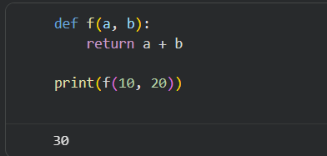
Issues Identified:
- Function name f is unclear
- Variable names a and b lack meaning
- Poor readability
Improved Code:
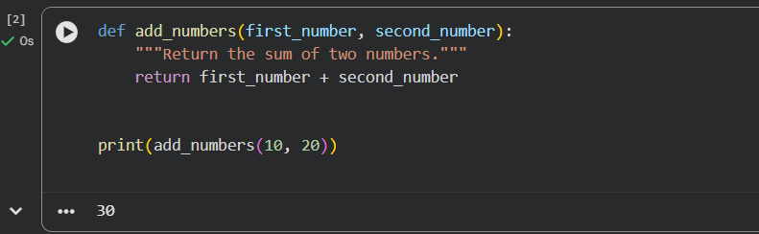

Improvements:
- Meaningful function and variable names
- Added docstring for clarity
- Improved readability and maintainability

Task Description #2 – Missing Error Handling
Given Code:
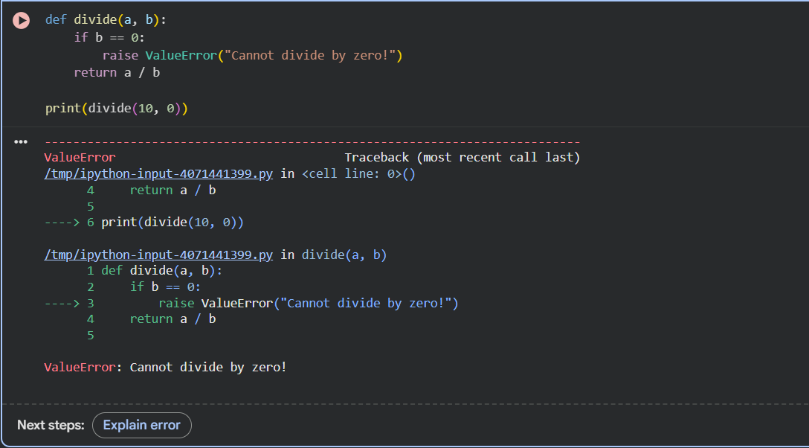
Issues Identified:
- No error handling for division by zero
- Program crashes at runtime

Improved Code:
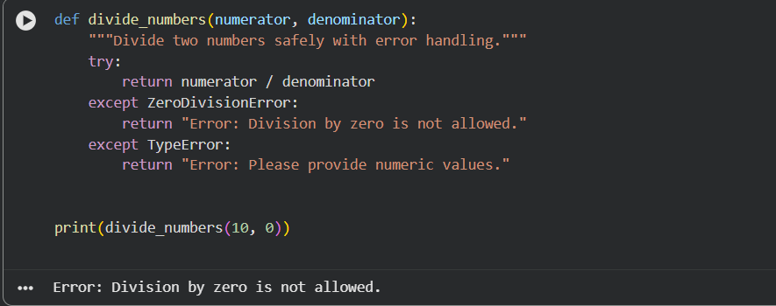
Improvements:
- Added exception handling
- Clear error messages
- Prevents runtime crashes

Task Description #3 – Student Marks Processing System
Given Code:
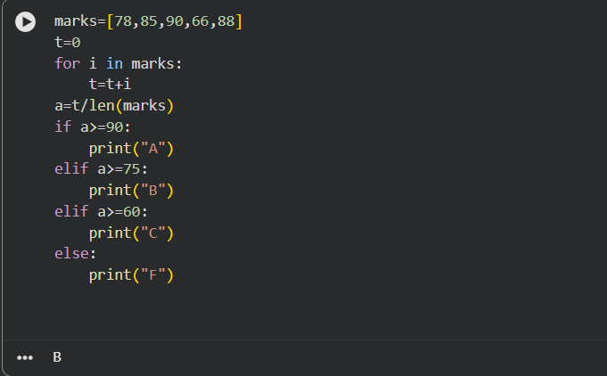

Issues Identified:
- Poor variable names
- No functions
- No validation
- Not PEP 8 compliant

Refactored Code:
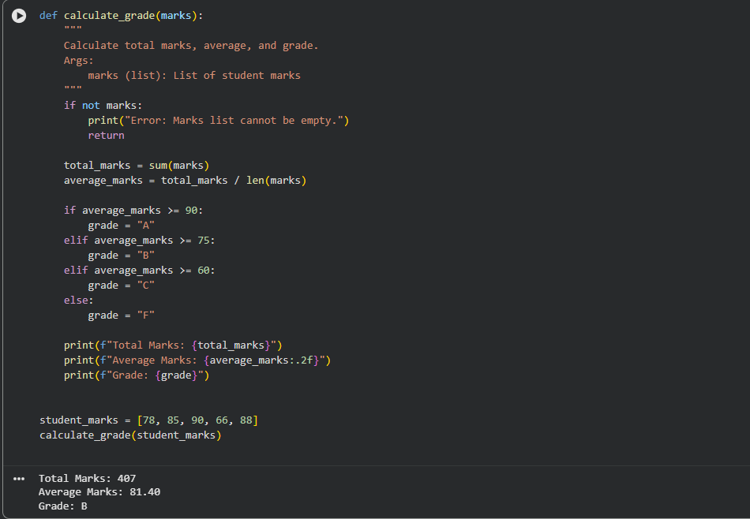
Improvements:
- Follows PEP 8 standards
- Meaningful variable names
- Modular function-based design
- Added documentation and validation

Task Description #4 – Add Docstrings and Inline Comments
Improved Code:
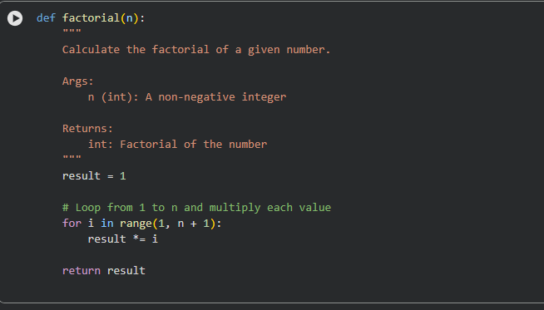
Improvements:
- Clear docstring explaining purpose, parameters, and return value
- Inline comments for better understanding

Task Description #5 – Password Validation System (Enhanced)
Original Code:
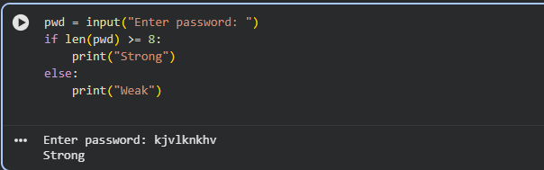

Limitations:
- Checks only password length
- No real security
- Not reusable
- Poor readability
Enhanced Code:
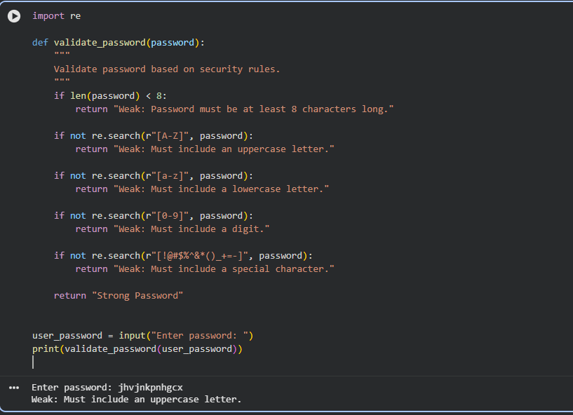

Comparison and Analysis
1. Code Readability and Structure
- Clear function-based design
- Meaningful variable names
- Clean and readable logic
2. Maintainability and Reusability
- Password validation logic is reusable
- Easy to modify or extend security rules
3. Security Strength and Robustness
- Enforces industry-standard password rules
- Reduces risk of weak passwords
Justification of AI-Generated Improvements
- Length check ensures baseline security
- Uppercase and lowercase checks prevent predictable passwords
- Digit requirement increases complexity
- Special characters reduce brute-force success
- Refactoring improves clarity, testability, and maintainability

Conclusion
This lab demonstrated how AI-assisted code review can significantly improve:
- Code readability
- Error handling
- Security
- Maintainability
- Compliance with PEP 8 standards
The refactored programs are safer, cleaner, and suitable for real-world applications.

